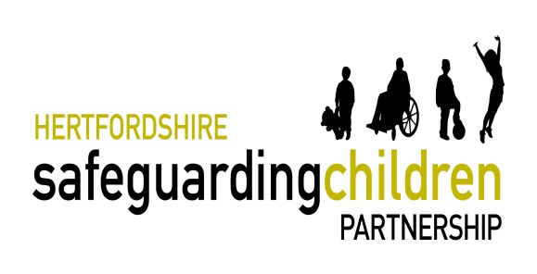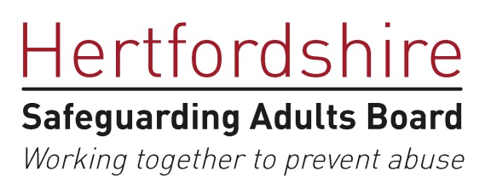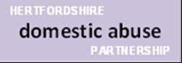
Live webinar (via Zoom)

An introduction to
Adverse Childhood Experiences,
Trauma Informed Practice and Resilience

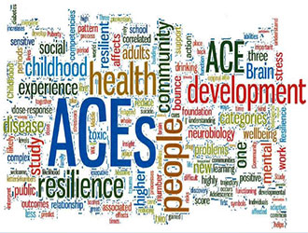

This training will introduce you to the science of Adverse Childhood Experiences (ACE’s) and the potential impact ACEs can have across the life course in terms of social, emotional and physical wellbeing. The sessions will explore the role of toxic stress and trauma on childhood development and adult life. The session will conclude by focussing on how resilience can offset the impact of adversity and trauma.

12 Nov 2020 - 9:30am, 11:30am or 2pm
17 Nov 2020 - 9:30am, 11:30am or 2pm
18 Jan 2021 - 9:30am, 11:30am or 2pm
28 Jan 2021 - 9:30am, 11:30am or 2pm
16 Feb 2021 - 9:30am, 11:30am or 2pm
11 Mar 2021 - 9:30am, 11:30am or 2pm
To book a place, please click on the link

