Referral form  Online Healthy Families group programme  Herts Valley CCG  The online Healthy Families programme is an early intervention supporting families with children under 5 years to adopt healthier lifestyles. |  | 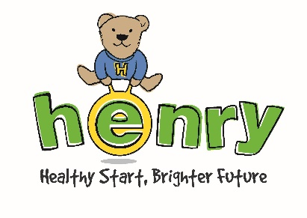
A structured 8 week programme (including a family time session), the group programme applies a solution-focused and strengths-based approach to build parents’ skills and confidence in maintaining a healthy lifestyle.
Please note that all referrals must be made with the consent of the family. You will be asked to confirm that you have gained the parent(s)’s consent at the end of this form.
To request support for a family, please complete the form below and return it to HENRY.
Please provide some details about the family:
Name of parent(s) or carer(s):
Name(s) and age(s) of children:
(n.b. the family must have at least one child under 5 years and must be registered with a HVCCG GP)
Address:
Contact phone number(s):
Email address:
Does the family have any language, mobility or communication needs we should be aware of?
Which eligibility criteria does the family meet (please tick next to criteria family meets)
BMI >91st centile
Or two of the following risk factors :
- 1+parent overweight or obese
- older sibling overweight or obese
- rapid weight gain (2 centiles crossed)
- Hieght and length centiles more than 2
- parent has poor diet
- child less than 1 hour physically active per day
- child screen time 2 hours+ per day
- Parent has weight/eating/oral health concern
- Early intro of solids (before 6 months)
- Poor responsive feeding techniques, poor sleep patterns.

What would the family like to achieve?
Form continues on the following page
Referrer details:
Name of referrer:
Role:
Address:
Contact phone number(s):
Email address:
Using this form to request support
Once you have gained the parent(s)’s consent to refer them to HENRY and have signed below to confirm this, please complete this form and return it according to the instructions below:
Email (preferred) |  |  | Alternatively,
- Password-protect and save this form  - Email to gemma.akinade@henry.org.uk  - Separately, email password to the same address |  |  | Call BeeZee Bodies on 01707 248648
We will use your information to process this referral and to contact you about future HENRY programmes
If you wish to discuss this referral (or how to send it) please ring Gemma on 07720090922
PRIVACY NOTICE & DATA PROTECTION
You are submitting this referral form to HENRY, a registered charity. HENRY will use the personal information here to refer the parent to the Healthy Families programme in Oxfordshire. We will also use anonymous data from this form to evaluate parent engagement with the HENRY programme.
All information will be kept securely and confidentially by HENRY. We retain referral forms for up to 3 years after receiving them. If you or the parent would like to know more about how HENRY uses and protects your personal information, and your rights, please see our Privacy Policy at www.henry.org.uk/privacypolicy, or contact us using the details at the foot the page.
By submitting this form, you affirm that you will handle the client’s personal information with due respect to their privacy, data security and rights in accordance with the relevant regulations. If you need to retain a copy of this form, or any information herein, please note that it is your or your organisation’s responsibility to ensure that the client is informed of this and that their information is held securely in compliance with the relevant data regulations.
☐ Please tick here to confirm that you have gained the client’s informed consent for their personal information to be shared with HENRY, and that you have read and understood the statement above.
Name of referrer: |  |  |  | Date:

