Marketing material for the Welwyn Hatfield Healthy Hub website launch 11th January 2021

Image for marketing campaign
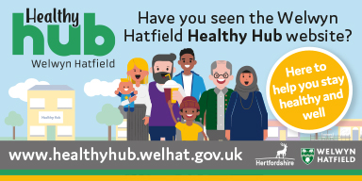

Introductory Text –Please send this out on the 11th January 2021
The new Welwyn Hatfield Healthy Hub website is now live! Check out healthyhub.welhat.gov.uk – here to help you stay healthy and well.
The Welwyn Hatfield Healthy Hub Website is now live. It is everyone’s one stop shop, connecting you to local health and wellbeing events, news and support services.
Most of us know that we should be eating healthily and keeping active, but sometimes we need a little help to get us on the right path. The Healthy Hub provides all of us in Welwyn Hatfield, with access to local advice and services to help us all do just that.
The Welwyn Hatfield Healthy Hub uses the Five Ways to Wellbeing to help connect residents to the vibrant Welwyn Hatfield health and wellbeing community and provide an easy to use tool to help develop healthy habits.
Fancy getting fitter during lockdown? Take a look at the Healthy Hub website news and events page for online sessions to help you be more active or learn a new skill or take part in an online music class or cookery class. Even though we are still isolating there is so much going on in our health and wellbeing community to support you.

Click on this link to access the website
Healthy Hub - Welwyn Hatfield Borough Council - Working better, together (welhat.gov.uk)

